I. SOIL

1. Namix Flower Soil

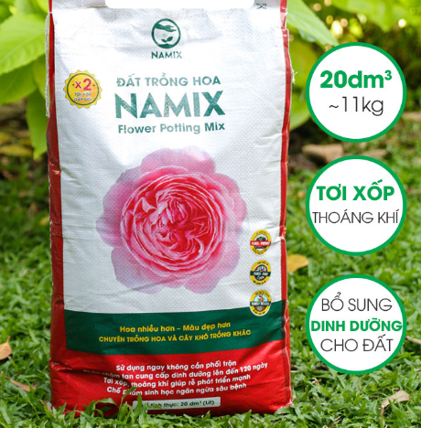

2. Namix Bonsai and Ornamental Plant Soil

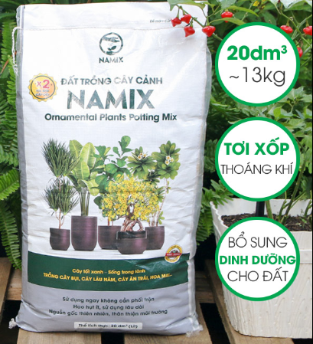

3. Namix Cactus and Succulent Soil

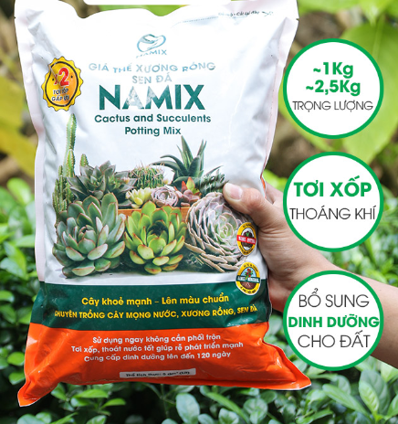

4. Ficoco ornamental foliage growing medium

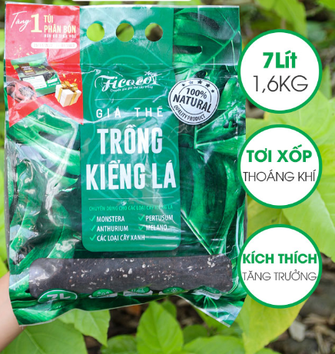

5. SFARM Organic Clean Soil for Growing Flowers and Ornamental Plants

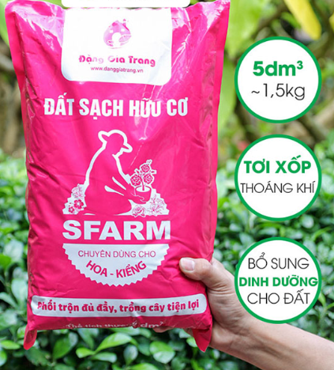

6. SFARM processed pure coconut peat

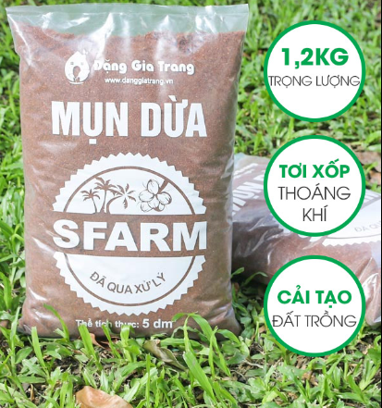

II. Fertilize

1. Microbiological product EM Trichoderma Plus SFARM (200gr)

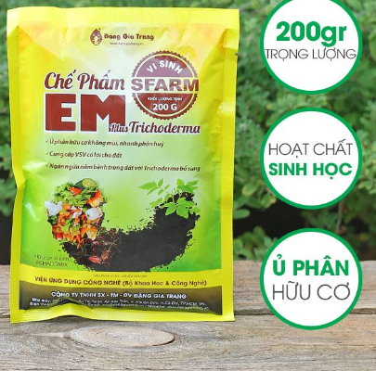

1. Minro 5-5-5+TE organic mineral fertilizer (1kg)

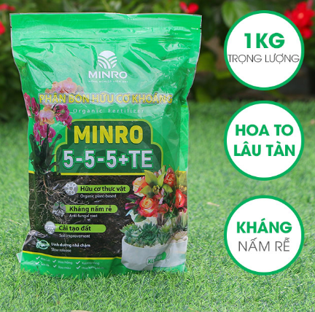

1. Minro 650M Organic Fertilizer for Bougainvillea (1kg) 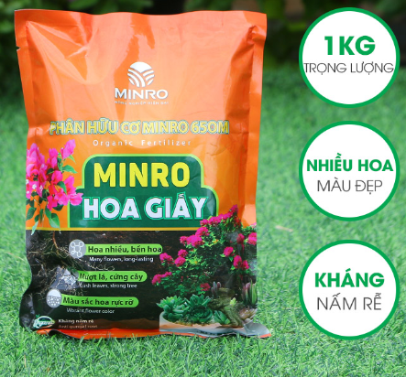

,

1. Dinamic Australian organic fertilizer (1kg)

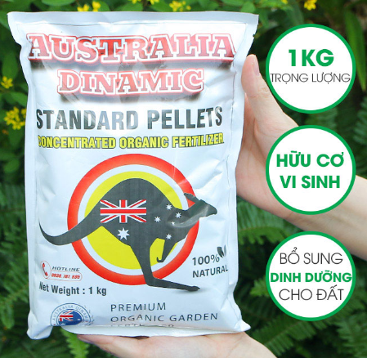

1. Lavamix pure vermicompost (2-5kg)

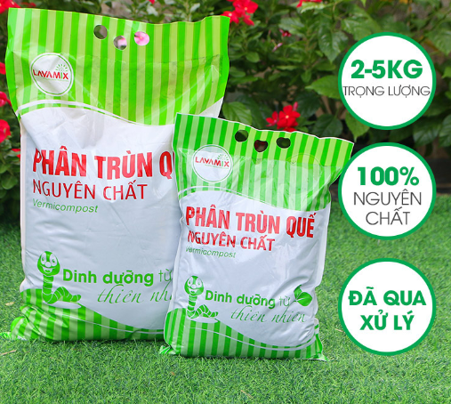

6. Japanese organic chicken manure pellets (1kg)

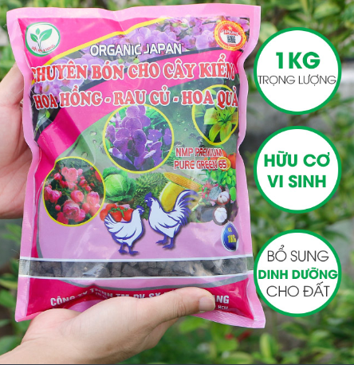

III. Medicine for plants

1. Microbiological product EM Trichoderma Plus SFARM (200gr)

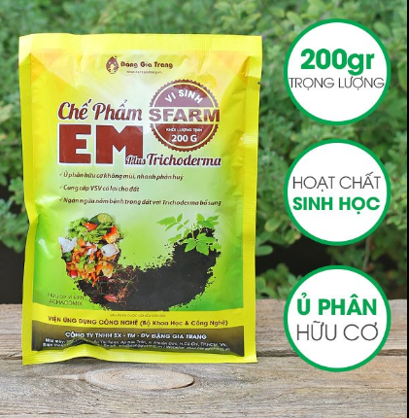

1. Combo of EM Trichoderma Plus Organic Fertilizer + SFARM Molasses

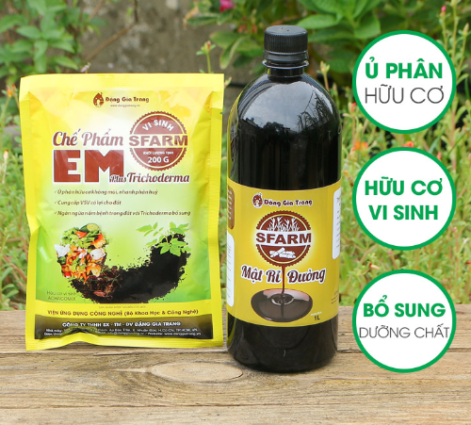

1. LS 50 plant scar healing glue (25 - 100gr)

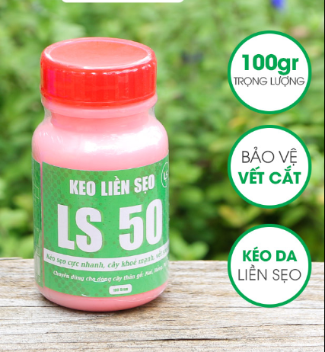

1. LS 80 plant bud stimulant glue (30gr)

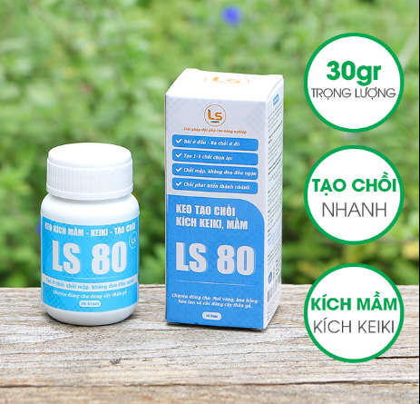

1. Thai snail killer (250-500gr)

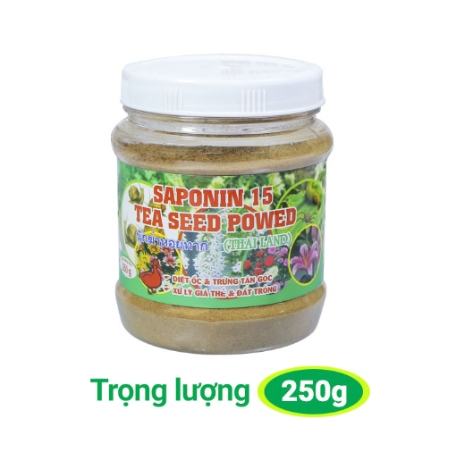

1. Neem Chito Dien Trang special medicine for leaf burn, wilt, soft rot (150ml)

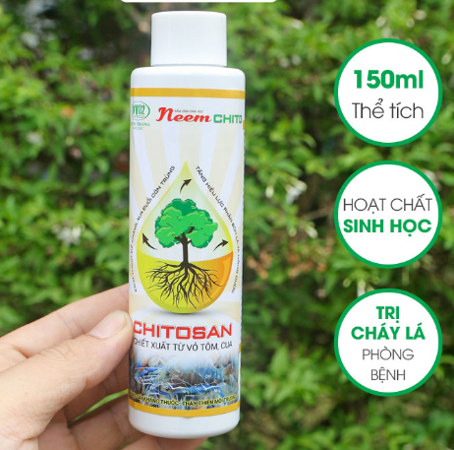

IV. Seeds

1. Multi-colored single Man Dinh Hong flower seeds RD 819

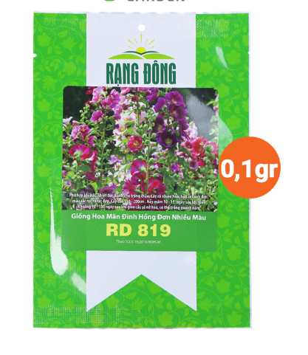

1. Butterfly Pea Flower Seeds RD 861

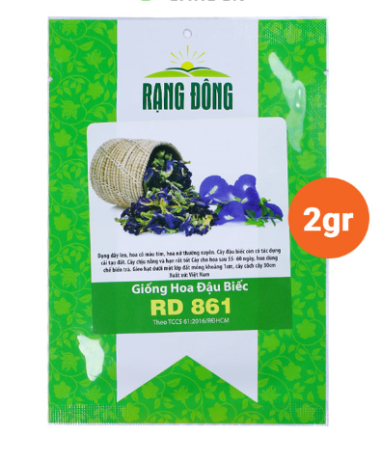

1. Multi-colored Aster seeds RD 921

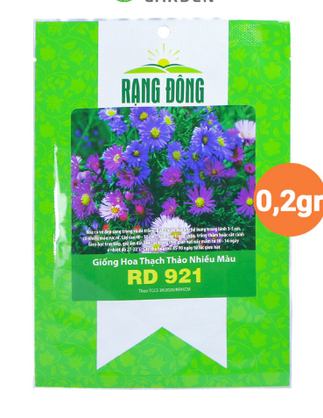

1. Rado 49 F1 long-fruited squash seeds 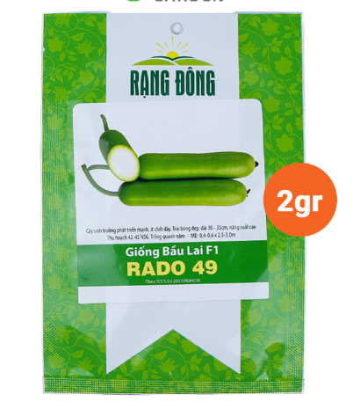
2. Sweet Cherry Tomato Seeds Hybrid F1 Orange Charm 403

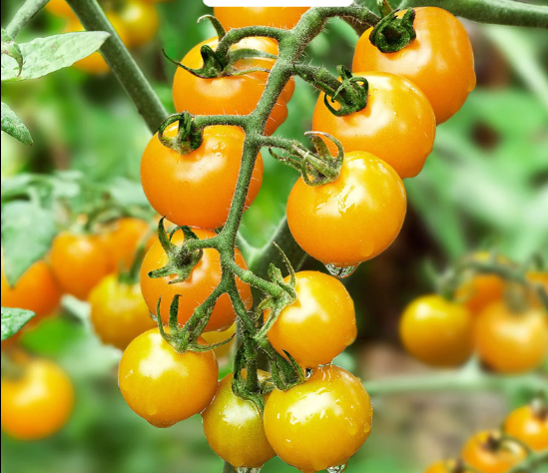

1. Rado 316 F1 hybrid long fruit bitter melon seeds

